A new Association President: Paul De Cock succeeds Ludger Schindler

Meeting of the EPLF in Sweden

On May 16 and 17, around 70 attendees gathered in Viken, Sweden, for the Annual General Assembly of the EPLF e.V., the Association of European Producers of Laminate Flooring. The meeting was hosted by associate member Välinge Innovation Sweden AB. After 16 successful years at the head of the Association, Ludger Schindler (MeisterWerke Schulte) stepped down from his position and members unanimously elected former Vice-Chairman Paul De Cock (Unilin) as the new EPLF President.

Viken marked the end of an era for the EPLF: after 16 years in office, Ludger Schindler (MeisterWerke Schulte) was no longer standing for re-election. A dedicated President, he has led the Association (which is now 24 years old) with a great deal of personal commitment, keeping it successfully on track. Mr Schindler has given great impetus to the further development of the EPLF (recent examples are the Innovation Forum “Laminate 2020” for members, and the EPLF Innovation Manifesto), thereby setting the Association’s future strategic course. Ralf Eisermann (Windmöller GmbH), formerly a fellow member of the Executive Board and a long-term business associate of Mr Schindler, gave a witty tribute speech at the meeting in honour of the outgoing President.

Honorary presidency for Ludger Schindler

Ludger Schindler was unanimously nominated as Honorary President of the EPLF in recognition of his significant contribution to the Association. This special title was last awarded in 2002 to founding committee member Ulrich Windmöller. In lines with the members’ vote, Paul De Cock (Unilin) will now succeed Schindler and take over the helm in the role of President. The EPLF Executive Board has been reduced from four people to three: at the Executive Board elections, Max von Tippelskirch (Swiss Krono) was confirmed as Vice-Chairman and Convenor of the Markets & Image Committee for another two years. Members also nominated Eberhard Herrmann (Classen) as successor to Dr Theo Smet, Acting Convenor of the Technical Committee on the EPLF Executive Board since 2016. Mr Herrmann has held this office once before, between 2014 and 2016. Dr Smet will continue to support the EPLF in an advisory capacity, which will include acting as a representative of the Association at CEN and ISO level. Another nomination at the Viken meeting was Georg Kruse (Windmöller GmbH), who was confirmed as Auditor of the Association. All votes were unanimous, and with its new Executive Board line-up now in place the EPLF considers itself well equipped for the tasks that lie ahead.

One of the strategic courses of action discussed at the members’ meeting was the implementation of an important joint project – the founding of a “European Floor Coverings Association” (EuFCA) in Brussels. This is to be made up of ECRA (European Carpet and Rug Association), ERFMI (European Resilient Flooring Manufacturers' Institute) and MMFA (Multilayer Modular Flooring Association). After a positive vote within the other three associations, EPLF members also unanimously granted their new Executive Board a mandate to establish the “EuFCA” EU umbrella organisation. In addition, Paul De Cock announced that the EPLF will relocate its Head Office to Brussels in the course of 2019, stating: “As the EPLF is a European interest group, being located in Brussels will be advantageous for our intensive lobbying.”

Innovation Manifesto: Strategy for the future of laminate flooring

“Innovation is the most important form of insurance for the future success of European laminate flooring – and the EPLF wants to continue providing crucial impetus in the process.” Ludger Schindler emphasised these words to EPLF members in Viken. With the publication of its Innovation Manifesto last year, the EPLF has reaffirmed its pioneering role within the industry. This is a strategy document that formulates the underlying concept of the EPLF and defines the guiding principles for its future work. At the meeting, the new Executive Board confirmed its resolve to implement this fundamental policy. One of the key elements of the Innovation Manifesto is the EPLF Innovation Award, to be awarded for the first time at Domotex 2020 in Hanover. As well as stimulating “sporting” competition between EPLF members, the primary focus of the award is to communicate the innovative strength of the European laminate industry. The concept aims to create an international industry platform for the long-term communication of the EPLF’s sustained and wide-ranging commitment to innovation.

Laminate sales up slightly

Max von Tippelskirch presented the current sales statistics at the Viken meeting: EPLF members have been able to increase laminate sales globally. Western Europe, including the principal German market, was slightly weaker compared to the previous year. In contrast, the North American, Asian and Eastern European markets in particular have increased considerably over the same quarter in the previous year. At the previous day’s session, the Markets & Image Committee had made the decision to step up its internal monitoring of the market so as to gain a better overview of the situation. Attendees were able to gain a deeper understanding of key aspects of competition law: lawyer Dr Christina Malz (SZA Rechtsanwaltsgesellschaft mbH, Mannheim) gave an informative talk on “Competition Law – Handling Risks and updated Legislation – Strategy and Daily Business: Caution is advised!”. Susanne Klaproth (Deutsche Messe AG, Hanover) reported on the planning of worldwide Domotex fairs for 2019.

Progress in standardisation – two new project groups in the EPLF

Dr Theo Smet presented the current trends in research and standardisation. With immediate effect, two new working groups in the EPLF will be dealing in-depth with the current laminate topics “micro-scratches/polishing effect” and “standing water resistance”. The aim is to work together on compiling a clear definition of terms, issuing practice-based classifications and, ultimately, on developing meaningful and reproducible test methods for product evaluation.

The sponsored “Castor Chair Test” is still underway and is set to run until August 2019. It involves EPLF experts working in collaboration with the IHD Wood Technology Institute Dresden to develop new test procedures and test devices. On the subject of “deeply-textured surfaces”, the EPLF has proposed an annex to EN 13329 at CEN level, which is to incorporate the new test methods from the Association’s successful pilot project. The revision of EN 14041 (Resilient, textile and laminate floor coverings - Essential characteristics) was adopted in May 2018, so publication of the revised standard will still be possible this year. An official Guidance Paper, issued by the CEN with the cooperation of the EPLF, will serve as a “user guide” towards a better understanding of the numerous amendments. Included in the updated version of EN 14041 is a series of new flooring pictograms plus increased requirements for so-called “hazardous substances”.

There has been further success with regard to documentation: in May 2018, the draft revision of EN 16354 was officially confirmed in the final vote. This standard sets down test procedures for determining the technical characteristics of underlays installed beneath laminate flooring and also minimum performance requirements for the flooring system (“Laminate floor coverings - Underlays - Specification, requirements and test methods“). The EPLF looks upon this revision as important progress, since the EN standard 16354 guarantees technical comparability of different underlay materials. The revised version will continue to promote competition between businesses to raise the quality level of these products. As a result, all customers will benefit from improvements to the entire system of laminate flooring. Dr Smet once again highlighted the strategic significance of the international standardisation work carried out in the ISO committees. As the world’s largest and foremost single association for laminate flooring, the EPLF will continue to consistently represent the interests of the European industry within the International Organization for Standardization, and remain committed to a steady improvement in global product standards.

The EPLF ideas pool: 3rd Innovation Forum

After intense sessions on day one for the expert Technical plus Markets & Image working groups, the second day of the Association meeting was devoted to the third “Laminate 2020 - Forum of Innovations”, during which EPLF networkers were given an information package on key industry developments of an innovative nature. Göran Ziegler (Välinge) gave the presentation “Innovation is our Mission – The Bridge between Laminate Flooring and Powder Technology”. Dr René Pankoke (Hymmen) gave an informative talk on “Innovative Production Technology for Laminate Flooring - continuous and flexible". The external speaker was Hannes Bäuerle (Raumprobe, Stuttgart), who reported on “New Haptics, new Looks, new Demands - Trends in Interior Decoration: Colours & Materials“.

Further EPLF working group sessions have been scheduled for the rest of the year.
Next year is a special year for the EPLF as it will be celebrating its 25th anniversary. The 2019 General Assembly will be held next spring at the invitation of the Beaulieu Group in Belgium. www.eplf.com

Illustrations - Image captions
elnd1804_b01a/01b:
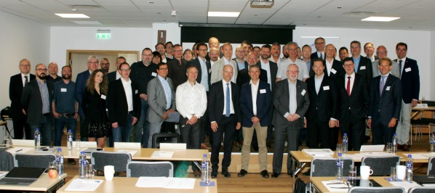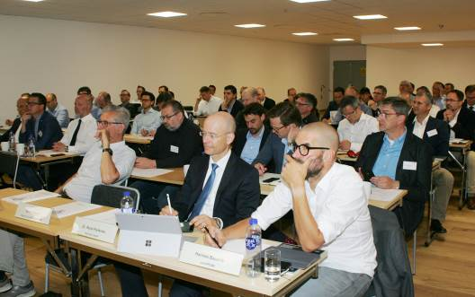
On 16 and 17 May, members of the EPLF e.V. gathered in Viken, Sweden, for their 2018 Annual General Meeting at the invitation of member company Välinge Innovation Sweden AB. – Photo: EPLF
elnd1804_b02:
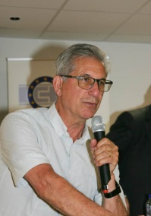
Meeting host and founder of Välinge, Darko Pervan, reminded the meeting about laminate flooring’s Swedish roots. – Photo: EPLF

elnd1804_b03:
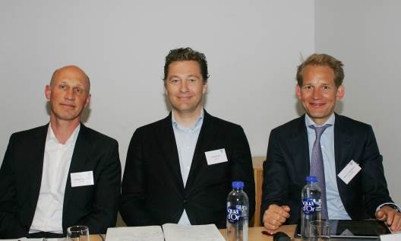
The newly-elected EPLF Executive Board line-up in Viken on 17 May 2018 (l. to r.): Chairman Eberhard Herrmann, President Paul De Cock and Vice Chairman Max von Tippelskirch. – Photo: EPLF

elnd1804_b04:
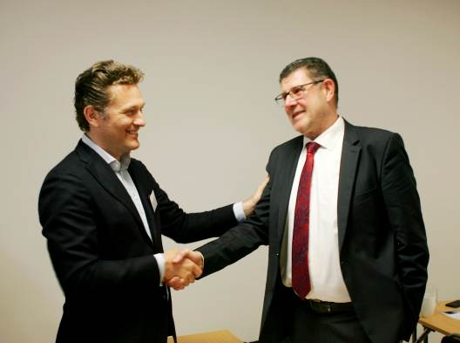
EPLF General Assembly in Viken, 17 May 2018: Ludger Schindler (r.) gives up his post after 16 years in office. The new President of the Association is Paul De Cock (l.). – Photo: EPLF

elnd1804_b05:
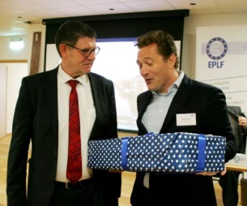
EPLF General Assembly in Viken, 17 May 2018: New President Paul De Cock presented his predecessor Ludger Schindler with the special gift of a soprano saxophone. – Photo: EPLF
elnd1804_b06:
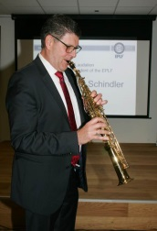
Ludger Schindler took the opportunity to try out his new instrument straight away. – Photo: EPLF

elnd1804_b07:
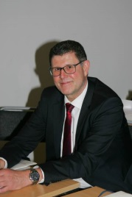
Ludger Schindler was unanimously nominated by Association members in Viken as Honorary President of the EPLF. – Photo: EPLF
elnd1804_b08:
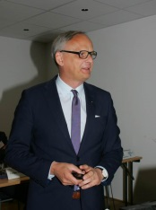
As his long-term business associate, Ralf Eisermann (Windmöller) gave a tribute speech to the outgoing EPLF President Ludger Schindler. – Photo: EPLF

elnd1804_b09:
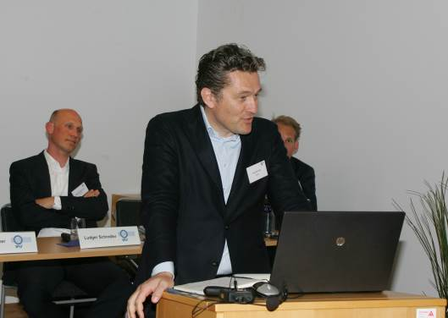
“Big tasks lie ahead for the EPLF.” – The new President of the Association, Paul De Cock, announced plans in Viken to relocate the EPLF to Brussels. – Photo: EPLF

elnd1804_b10:
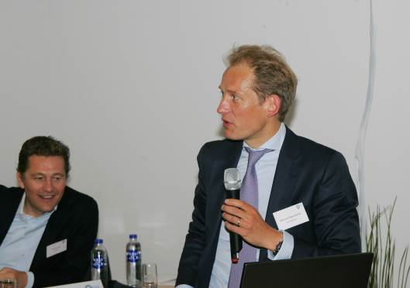
Max von Tippelskirch, Vice-Chairman and Convenor of the Markets & Image Committee presented the quarterly figures at the Viken meeting: “EPLF members have been able to increase global sales of laminate; however there has been a renewed decline in sales in Western Europe and Germany.” – Photo: EPLF

elnd1804_b11:
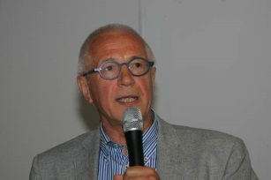
At the meeting in Viken, Dr Theo Smet underlined the important role of the international standardisation work carried out by the CEN and ISO committees. – Photo: EPLF

elnd1804_b12:
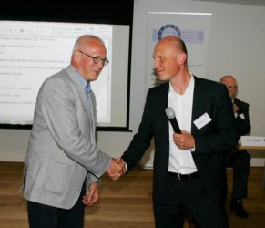
Eberhard Herrmann (r.), new Convenor of the Technical Committee, thanked Dr Theo Smet (l.) for his hard work within the EPLF Executive Board. – Photo: EPLF

elnd1804_b13:
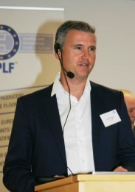
At the third Laminate 2020 - Forum of Innovations, Göran Ziegler (Välinge) held a presentation on “Innovation is our Mission – The Bridge between Laminate Flooring and Powder Technology”. – Photo: EPLF

elnd1804_b14:
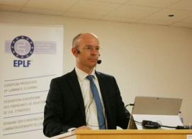
Dr. René Pankoke (Hymmen) gave an informative talk on “Innovative Production Technology for Laminate Flooring - continuous and flexible”. – Photo: EPLF

elnd1804_b15:
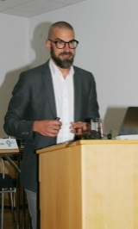
External speaker Hannes Bäuerle (Raumprobe, Stuttgart) reported on “New Haptics, new Looks, new Demands - Trends in Interior Decoration: Colours & Materials”. – Photo: EPLF

