25 years of the EPLF:
Europeans look to the future with confidence

The European network of the EPLF – the Association of European Producers of Laminate Flooring – is made up of 18 laminate flooring producers, 20 supplier companies and 10 supporting members. This is the world’s largest regional association for the laminate industry and it celebrates its 25th anniversary in 2019. In light of growing competition in the traditional markets, EPLF players are showing confidence and are focusing on their special strengths.
In 2017, EPLF members still accounted for around half of global laminate sales which amounted to over 1 billion square metres. From a worldwide perspective, laminate flooring is still experiencing growth and it is only in Western Europe, particularly in Germany, that sales have been declining for a while. Trends towards substitution are becoming evident, especially in regions with strong purchasing power. EPLF producers are currently benefiting from being well-positioned in terms of worldwide exports and the fact that sales of European laminate flooring are continuing to improve in Eastern Europe, Asia, North and South America. Collaborative work is being carried out within the EPLF on developing the potential of laminate – especially with a view to the European domestic market.

Flooring markets are in the midst of change; customers today have new and very individual requirements. They want a modern type of floor covering that corresponds exactly to their usage requirements. And this is where European laminate floor coverings can make good use of their advantages and impressive selling points: they are technically advanced after decades of development work, their design quality is superb and they represent very good value for money. European laminate is produced sustainably - it is eco-friendly because it uses renewable resources, economically efficient because it is produced in large quantities using advanced technologies, and it is socially responsible due to fair and regulated working conditions and employment relationships.

Continuously-evolving products

A particular strength of the European laminate flooring industry lies in its innovative strength. The EPLF wishes to retain its strong leading role in this area by working together to develop European laminate flooring with a view to satisfying the needs of customers in the best way possible. This remains the stated goal of EPLF leaders following the departure of Paul De Cock (Unilin), who had been elected as the new EPLF President in May 2018 but as a result of new responsibilities in North America he had to step down in autumn 2018. Since that time, Max von Tippelskirch (Swiss Krono Group) has taken over his duties in the role of Vice-Chairman of the Board. Mr von Tippelskirch continues to chair the Markets and Image Committee. Working alongside him as Convenor of the Technical Committees is Executive Board member Eberhard Herrmann (Classen). EPLF members will elect a new President at their Annual General Meeting to be held in Belgium in June 2019. The EPLF Executive Board strategy for 2019 had already been decided in agreement with Paul De Cock, which is why the work of the Association continues to proceed as normal. The EPLF was pleased to welcome another stakeholder to the network at the beginning of 2019 when laminate manufacturer Rezult LLC (Kiev, Ukraine, www.rezult.pro) was accepted into the organisation as an ordinary member.

Working together to drive innovation

The EPLF perceives itself as a driver, boosting and accelerating innovation. Its 2017 Innovation Manifesto defines the goals and strategic framework for future activities. Since 2016, the “Laminate 2020 - Forum of Innovations” has provided an effective setting for exchanging information on new approaches and supplier technologies. Associate members of the EPLF use the forum to present their ideas and new concepts, thereby providing laminate producers with valuable and thought-provoking impulses. This joint network enables the Association to give state-of-the-art European laminate flooring a dynamic push forward. Innovation efforts are also accompanied by quality assurance measures, namely the EPLF research projects and its involvement in standardisation work at CEN and ISO level.

Digitalisation presents new challenges for the industry. It brings opportunities for process optimisation, greater flexibility and speed in production processes and better inventory management, leading to an overall quicker response to changes in demand. This applies to digitalisation in general as well as to digital printing specifically. Many EPLF members have advanced production facilities which enable them to benefit from these new opportunities. Digitalisation also offers options for developing employee expertise more consistently – after all, these are the people who will improve the products and their level of innovation and future-proofing.

Digitalisation brings a new kind of transparency to the markets. It helps to communicate the superior design quality of European laminate more effectively and provides better guidance for the trade and customers all around the world. Lastly, digitalisation makes things harder for imitation products and dubious labelling, something that many people still fall prey to the world over.

New EPLF research projects underway

Summer 2018 saw the start of new research projects for the EPLF: moisture resistance and micro-scratches/polishing effects. Both these topics reflect the current state of product development. Regarding the first topic, the range of moisture-resistant laminate flooring for installation in kitchens, bathrooms and utility rooms is increasing. To be able to compare and assess the quality of these products, the EPLF is working on a suitable classification system for resistance to moisture. The second topic stems from the degree of gloss of easy-care laminate floors. More technical knowledge is needed on how micro-scratches occur on gloss or high-gloss surfaces and what causes the polishing effect on matt surfaces. The Association wants to establish clear definitions for these studies, issue practically-oriented classifications and ultimately develop meaningful, reproducible test methods for product evaluation.

The EPLF “Chair Castor” project, which aims to develop new test procedures and testing equipment, will run until August next year. Experts at the EPLF are also actively involved in all revision processes for standards. The new EN 16354 standard assures the future technical comparability of different flooring underlays. In addition, the revision of EN 14041 “Resilient, textile, laminate and modular multilayer floor coverings. Essential characteristics” was approved in spring 2018. An official Guidance Paper, issued by the CEN in collaboration with the EPLF, will act as a “user guide” and contribute towards better understanding of the many amendments.

The EPLF becomes even more European

There are more key dates lined up for the EPLF in 2019, one being that the organisation is now 25 years old! Members will celebrate the anniversary on 5 and 6 July at the Annual General Meeting to be hosted in Antwerp (Belgium) by the Beaulieu group of companies. Together with various European associations – ECRA (carpets and rugs), ERFMI (resilient floor coverings) and the MMFA (multilayer modular flooring), the EPLF has founded the EuFCA, which stands for European Floor Covering Association. In this way, the EPLF is now present in Brussels – located close to the European institutions and decision-makers. Whether the EPLF Secretariat will also be located there in the future depends on how the management is governed. – A change in personnel is also on the cards for 2019: after 22 years as Managing Director of the EPLF, Peter H. Mayer is preparing to retire.

After 25 years of existence, the EPLF is entering a new and exciting phase. Its members and the Executive Board have set themselves high goals. As Max von Tippelskirch confirms: “We are determined to continue on the European laminate road to success over the next 25 years!”
www.eplf.com

Images
Image captions
elnd1901_b1:
Max von Tippelskirch, Vice-President and Chairman of the Markets & Image Committee since 2014, assumed management responsibility after the departure of Paul De Cock. – Photo: EPLF

elnd1901_b2:
Re-elected as Chairman in May 2018, Eberhard Herrmann is also head of the EPLF Technical Committee. – Photo: EPLF
elnd1901_b3:
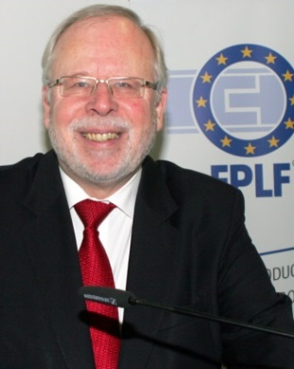
Peter H. Meyer, Managing Director of the EPLF since 1998, is preparing for retirement. – Photo: EPLF

elnd1901_b4:
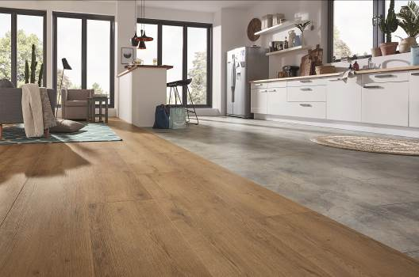
The objective of the EPLF is to secure a lasting future for European laminate. – Photo: Kronotex

EPLF Annual Press Conference on 12 January 2019, Domotex/Hanover:
elnd1901_b5: EPLF board members Eberhard Herrmann and Max von Tippelskirch at the Annual EPLF Press Conference, 12 January 2019 at Domotex/Hanover. - Photo: EPLF
elnd1901_b6: Max von Tippelskirch, commiss. EPLF president and Chairman of the Markets & Image Committee, reported on the association work and presented the latest EPLF sales figures. - Photo: EPLF
elnd1901_b7: Eberhard Herrmann, head of the EPLF Technical Committee, informed about the research projects of the association. - Photo: EPLF
elnd1901_b8: EPLF Annual Press Conference on 12 January 2019, Domotex/Hanover. - Photo: EPLF

