1994 to 2019: EPLF celebrates its 25th anniversary
Future focus: innovation, sustainability, quality and design

The EPLF celebrated 25 years of existence at its Annual General Assembly held in Antwerp. The Association of European Producers of Laminate Flooring is the representative organisation for leading producers in Europe and their supply companies. Founded in Bonn in 1994 and headquartered in Bielefeld since 1998, this year the management of the association will move to Brussels – closer to the European institutions and organisations it works closely with. Twenty-five years of the EPLF is reason enough to analyse the laminate flooring market, this time above and beyond current trends and tendencies – looking through a wide-angle lens, so to speak.

The anniversary wasn’t the only focal point at the meeting in Antwerp, however. Both the Technical Committee and the Markets & Image Committee worked intensively and set the course for important future projects. A new management board and new committee convenors were also elected: Max von Tippelskirch (Swiss Krono Group) as Chairman, Ruben Desmet (Unilin) as his deputy and Convenor of the Markets & Image Committee, and Eberhard Herrmann (Classen Group) as additional board member and Convenor of the Technical Committee. Georg Kruse (Windmöller) was re-elected as Auditor, a role he has held for several years.

EPLF’s new president Max von Tippelskirch appraises past, present and future with optimism: “With the present global political background in mind EPLF is celebrating its 25th anniversary in challenging times. Nevertheless our absolute market volume, international presence, technical expertise, creative design, inventiveness, financial strength and an ecological approach that’s unique in the flooring sector are excellent prerequisites for coping with structural changes in the domestic markets and some image deficit among consumers.”

No. 1 worldwide

Where does the EPLF stand today? Back in 1999, when all ordinary members, i.e. producers of laminate flooring made in Europe, reported fully on their sales for the first time, the figure stood at 132 million m², which was estimated to represent 60% of the world market held by the EPLF members’ European plants. The sales peaked at 507 million m² in 2007, immediately prior to the global financial crisis. The world market share for the EPLF at that time was 56% of the total 905 million m². In 2018, EPLF sales including certain extrapolated values from the Russian group of members stood at 483 million m², corresponding to a global share of almost 50%.

Two distribution channels which have been growing at a more or less equal level are specialist trade/specialist wholesale, which supply the vast majority of professional floor installers, and DIY distribution structures with do-it-yourselfers as their core target group. Currently, EPLF membership includes 18 laminate manufacturers from nine European countries, plus 30 supply companies and also renowned test institutes.

These figures make the EPLF the most prominent cross-company organisation in the laminate flooring industry. The comparable North American NALFA association has calculated its world market share at less than 10% (some EPLF members have dual memberships as they also manufacture in North America). There is no comparable industry association in China, where laminate flooring manufacturers are assigned to an organisation similar to an industry chamber of the wood industry, which runs under the control of the Ministry of Forestry.

In 2018, worldwide production and foreign trade could be roughly broken down as follows: China laid claim to more than a quarter of the world production, of which one sixth is exported. In second place, Germany has quite a different situation – just a little less than a quarter of the world production, with around 75% being exported. Ranking third in the list of producing countries is Turkey, with approximately 10% of the world production and minimal exports. Russia follows behind with 9% and 20% imports and, finally, the USA has 8% of the world production and significant imports from Europe and China.

The EPLF tagline ‘Quality and Innovation made in Europe’, which was introduced in 2013, was a step designed to strengthen the profile of European laminate flooring production in international markets. It succeeded, because today, laminate flooring made in Europe is sold to 127 countries.

The early days: fast-paced market dynamics between 1990 and 2008

By the end of the 80s/early 90s, the first laminate floors in Europe using melamine direct facing technology caused a sensation. Prior to that, HPL or CPL with wear-resistant overlay had been glued onto a composite wood core. This was a costly process resulting in products that were quite simply ‘over-engineered’ for everyday applications. HPL laminate floors played a limited role. The use of short-cycle presses was a disruptive innovation, as we would say today. Processes were massively shortened, everything happened fast – and laminate broke out of its niche.
The first laminate floorings have virtually nothing in common with the products sold nowadays, although this is seemingly not evident to many consumers. In the early 90s, planks were joined together with the classic tongue and groove profile. Specialists in technical committees argued about whether it was best to glue down floor coverings on the ground or lay them as floating floors. A popular sales argument for renovators in those days was to retain worn carpets as an underlay and simply ‘float’ the exciting new laminate flooring with its realistic oak or beech effect on top of it.

Since years floating installation became the undisputed state of the art. Eberhard Herrmann (Classen group), member of the executive board and convenor of the technical committee comments: “The early buyers may have had issues with gluing the tongue-and-groove connections or critical qualities from DIY promo sales. Compared to this, modern laminate floorings succeeded several leaps of technical development. Due to the ever advancing latest click-connections laminates are easy and stable to install. Together with the manifold underlay materials complete flooring systems were generated, making footfall sound and room sound controllable, securing an extended working life of the lockings. Innovative V-grooves with increased water resistance open doors to applications excluded in the past, for example kitchen and bathrooms.”

Environmental profile as a measure of all things

From an environmental and economic point of view, laminate floors have always been, still are and will remain one of the best floor coverings of all. They are predominantly made of wood and wood fibres or cellulose. Wood is a renewable resource, which is why laminate is classified as an environment-friendly, sustainable product. Laminate floors have a rigid, closed surface that is impenetrable to dust and dirt, making it hygienic, easy to clean and well suited to allergy sufferers. The EU Commission recognised this in 2017 with its upgraded policy enabling laminate flooring to gain the EU Ecolabel. This is something that has to be communicated more strongly in the future.

Thirty years of design, research and development have made European laminate one of the world’s most popular and best quality floor coverings. Laminate offers more: more variety in the choice of decors, more user comfort and more enjoyment from hard-wearing, environment-friendly flooring. Nonetheless the market surroundings for the flooring category laminate is tightening. Especially in Central Europe some people are still associating laminates with experiences from pioneer times. The technical advancements are not yet braced by any consumer. The EPLF is going to change this actively.

Where does laminate stand today – the Innovation Manifesto

“Standing still is like stepping backwards” which is why Ludger Schindler (MeisterWerke), EPLF-President from 2002 to 2018, led the industry to adopt the Innovation Manifesto in 2017. In this ambitious vision, EPLF members commit to tackling the challenges of the future just as innovatively and proactively as in the past. Categories in the manifesto include: experience, sustainability, market proximity, market presence, competition, qualification, constructive dialogue, development of standards, team spirit and courage – because innovation means opportunity and risk in equal measure.

The EPLF is currently discussing several initiatives to create a future-proof image through appropriate market communication strategies especially for the premium laminates of the newest generation (10 mm thickness and more, high wear resistance, water resistance, EIR-grains, V-grooves). Ruben Desmet (Unilin), EPLF vice-president and convenor of the markets & image committee states: “Properties of laminate floorings were optimized significantly in the recent years. In addition to the economical aspect, an unbeatable value-for-money ratio, customers buying laminate floors today are also making an environment-friendly choice, as about 80% of a laminate floor is consisting of sustainably sourced wood. Wood is growing back and even the disposal is environmental friendly. The new EPLF board is aiming at a mutual communication strategy to raise awareness of the consumers and partners within the distribution channels on all these benefits. This will bring more clarity.”

With a 25 year-long history, technically matured products, focused customer orientation, and the strong will to take new lines of market communication, EPLF stands ready for continued international expansion and to address the structural changes within the Western European home market. It is in this context that the EPLF is launching a far-reaching market survey in Germany, France and Poland to update the former 2006 and 2011 research projects, and is looking forward to another great presentation at Domotex 2020 in Hanover (Germany).
www.eplf.com

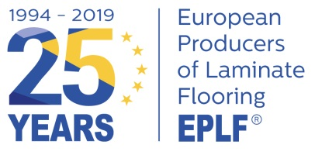

Anniversary logotype

Captions:

elne1907_05
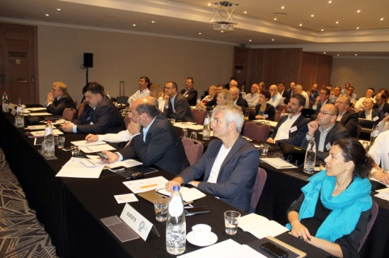
Full house at the EPLF Annual General Assembly in Antwerp.
Photo: © EPLF

elne1907_06
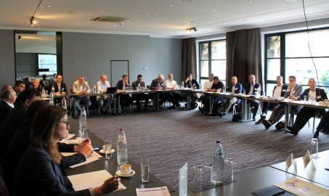
The Technical and Markets & Image Committees set the course for important future projects. Photo: © EPLF

elne1907_07
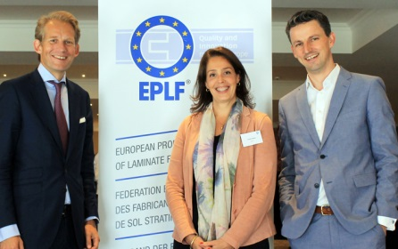
Leading the EPLF into the future (from l. to r.) Chairman Max von Tippelskirch (Swiss Krono Group), Managing Director Designate Feriel Saouli, Deputy Chairman and Convenor of the Markets & Image Committee, Ruben Desmet (Unilin), and (not pictured) Eberhard Herrmann (Classen Group), board member and Convenor of the Technical Committee. Photo: © EPLF

elne1907_08
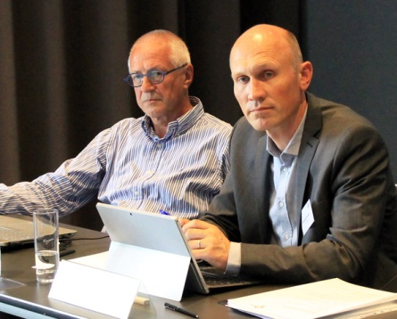
The technical backbone of the EPLF: Eberhard Herrmann (Classen Group), board member and Convenor of the Technical Committee, Dr. Theo Smet, long-standing technical consultant. Photo: © EPLF

elne1907_01
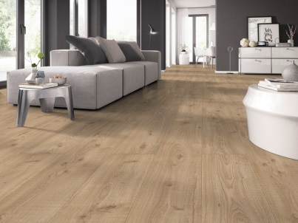
From an environmental and economic point of view, laminate floors have always been, still are and will remain one of the best floor coverings of all. Photo: © Classen Group, Oak rough-sawn Rustic Plank, from the “Spectrum” DIY collection

elne1907_02
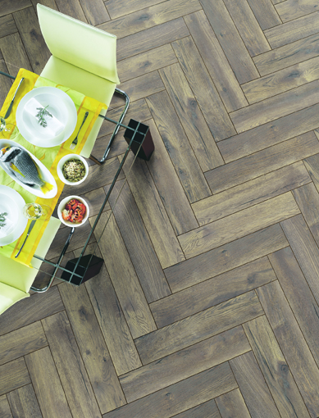
Modern laminate offers more: more variety in the choice of decors, more user comfort and more enjoyment from hard-wearing, environmentally-friendly flooring. Photo: © Swiss Krono Group, laminate flooring Swiss Krono Herringbone
elne1907_03
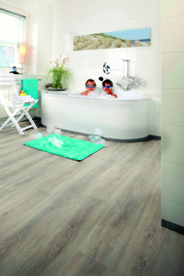
For today’s laminate flooring with increased moisture resistance, doors are opening up to application areas that were previously closed to them, such as bathrooms. Photo: © Windmöller – Wineo Aqua-Stop Ambiente

elne1907_04
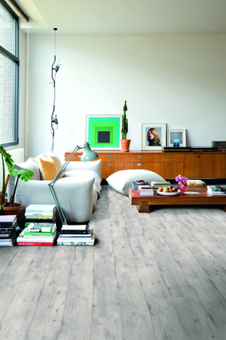
Ongoing innovation has taken today’s laminate flooring light years ahead of the pioneer products of 30 years ago. Photo: © Quick-Step - Impressive Concrete wood light grey

