Serving the world’s markets with premium quality and variety:
European laminate products combine innovation, ecology and design
There are compelling reasons why customers around the world are opting for European laminate – it is sustainably produced, boasts superb technical benefits and offers remarkable versatility in terms of decor. As a result of innovative product developments, these ever-popular laminate floorboards are now conquering moisture-prone rooms such as kitchens and bathrooms. High-tech laminate from Europe continues to represent the ultimate benchmark in the flooring segment, and not only in technological terms.

European laminate flooring producers are presenting their up-to-date ranges with a wealth of design features that make them suitable for any living or working space. Depending on their preferences and needs, customers can choose between products with different dimensions either in the classic tile format, as practical short planks or as generously-sized country style planks. Today, there are just as many facets to interior design worldwide as there are individual lifestyles. Ranging from “modern”, “urban retro” and “industrial” through to the enduring Scandinavian-inspired look, different trends are holding their own in the markets simultaneously – and quality laminate with the “Made in Europe” label is able to offer something to suit every taste.

Both the vintage look and the used look are still dominant themes in flooring. Also noticeable is the ongoing revival of the classics – herringbone, for example, available as single tiles or combined in larger boards, continues to be popular with customers. The demand for wider and longer plank sizes has been growing for several years, especially in Germany, Switzerland and Austria. This tendency has been facilitated by large, open-plan room concepts, where the boundaries between living areas are increasingly blurred. Alongside this, retaining a strong position in interior design and creating a countertrend to XXL boards are styles that use a combination of different plank formats or even short planks.
When it comes to choosing a decor, reproduction woods such as maple, beech, hickory, cherry, pine, walnut and elm are presented in a host of fresh varieties, although oak remains unsurpassed and this will probably continue to be the case. Timelessly beautiful, expressive and visually captivating time after time, oak can be combined with other materials as desired, making it the ideal starting point for the creative teams involved in product development. Manufactured with imaginative designs in a range of new colours, textures and dimensions, laminate oak decors have long been sought-after by international customers; indeed, oak effect boards are the bestsellers in the laminate collections, and this is set to continue. Lighter to medium dark shades and various grey hues continue to enjoy positive feedback, while laminate decors inspired by vibrant wood textures with end grain elements and growth rings are particularly eye-catching. These high-quality synchronous embossed surfaces have surface textures that are precisely matched to the wood grain pattern, and with finishes ranging from matt to semi-matt, they give a near-perfect, natural impression to the finished floor.
An abundance of styles for more choice in flooring

Alongside the huge selection of reproduction woods, laminate ranges also include modern stone design decors, e.g. marble effect, travertine, terrazzo and the contemporary concrete look in different variations, plus new surfaces incorporating metallic colouring or a fascinating rust effect. Overall, manufacturers are showing courage through their choice of colours and the unconventional designs in their collections. A modern and vibrant appearance enhanced by imaginative patterns and effects makes laminate flooring a stunning addition to any room. This wealth of variety and colour is an indication of the increasing use of industrial digital printing within the European laminate sector. Producers of mouldings and profiles are also using this technology to great effect, as the quickest and most flexible way of responding to frequent customer requests for a decor to match their chosen laminate floorboards. Suppliers have special designs available for specific architectural requirements, e.g. extra-slim skirting profiles allowing for accuracy of installation, even with narrow door frames. The new generation of floor transition profiles fully meets the need to offer a technically perfect covering with the smallest possible profile area, and the most popular surfaces finishes for these are polished, brushed and powder-coated.
Laminate flooring produced in Europe benefits from the latest production and printing technology and is continuously undergoing further development. Sophisticated click systems with profile sealing and special moisture protection features are opening up new application areas and customer target groups. These laminate solutions suitable for damp areas now make it possible to install the homely wood plank style in kitchens and bathrooms, too. They have a particularly non-slip surface and the requisite swelling protection is provided by newly-developed HDF core boards (extremely hard and dense) together with specially impregnated top layers and edges, all of which make the laminate boards more resistant to splashing and moisture.

European laminate flooring producers and their suppliers are motivated daily by their “Quality and Innovation made in Europe” label and will continue to increase the diversity of their premium quality products in laminate markets throughout 2019.
www.eplf.com
Images:
Image captions
elnd1807_b1:
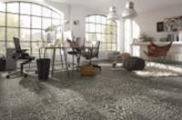
A modern and vibrant appearance plus imaginative patterns and effects make laminate flooring a stunning addition to any room. – Photo: Kronotex

elnd1807_b2:
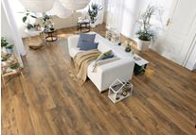
Ideal for open-plan room concepts: Over the last few years, the demand for wider and longer plank formats has been growing. – Photo: HARO/ Hamberger Flooring GmbH & Co. KG

elnd1807_b3:
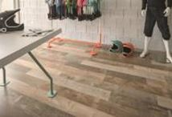
Both the vintage look and the used look are still hugely popular as a flooring choice. – Photo: KAINDL

elnd1807_b4:
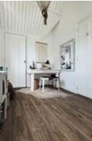
New colours, textures and sizes: Modern laminate decors replicating the look of real oak with a creative twist are increasingly finding favour with buyers. – Photo: Meister

elnd1807_b5:
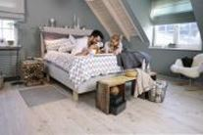
The new laminate decors in light pine effect fit in well with the much-loved Scandinavian style. – Photo: wineo

elnd1807_b6:
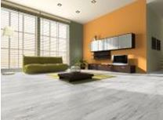
The on-trend concrete look appears in different variations on a large number of laminate surfaces. – Photo: Classen

elnd1807_b7:
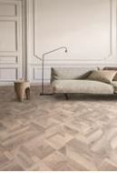
Revival of the classics: Herringbone interpretations as single tiles or combined in larger boards continue to be enormously popular. – Photo: Balterio - Premium brand by Unilin

elnd1807_b8:
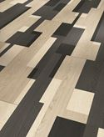
Sophistication: Combining different plank sizes and surfaces makes for attractive floorscapes. – Photo: Parador

elnd1807_b9:
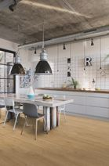
With laminate solutions available to suit damp areas, it is now possible to install the homely wood plank style in a kitchen or bathroom, too. – Photo: Quickstep - Premium brand by Unilin

